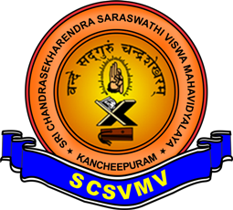
Sri Chandrasekharendra Saraswathi Viswa Maha Vidyalaya
(Deemed to be University u/s 3 of the UGC Act 1956)

DEPARTMENT OF COMPUTER SCIENCE AND APPLICATIONS
MODEL QUESTION PAPER - DEC 2025

SUB. NAME : ETHICAL HACKING SEM : III
SUB.CODE : UCYF233T40 COURSE : II BSc (Cy)
MARKS : 100 DURATION : 3 Hrs

Section A: ANSWER ALL THE QUESTIONS (10 x 2 = 20 marks)
- Define Common tasks of an Ethical Hacker
- Define Risk & Threat with an example
- Write short notes on different types of Backups
- Define Black-White-Gray hat hackers
- Discuss the different types of worms
- Define session hijacking
- Define SQL Injection
- List any five wireless technologies with purpose
- Define IDS and IPS
- Define Firewall and Honeypots

Section B: ANSWER ANY FIVE QUESTIONS (5 x 7 = 35 marks)
- What are the Skills and Rules for an Ethical Hacker
- Describe various steps involved in Hacking Methodology

Section C: ANSWER ANY THREE QUESTIONS (3 x 15 = 45 marks)
- (a) Explain the use of arrays with an example program to list food menu items name in a restaurant (8)

(b) What is the use of structures, Explain with an example (7)
- Compare and Explain switch-case and if-else-if to check keyed user input is Vowel or Consonants
- Explain various parts of Functions with your own User-Defined function and any two built-in functions
- Write a program to copy source text file contents to destination file with appropriate comments
- Create and Explain employee class object to explain the behavior of default and custom Constructors
*****

